My Own Book Fund Evaluation

Executive Summary
August 2014
Methodology
TCC Group partnered with My Own Book Fund (MOBF) to evaluate the My Own Book Program. We gathered data through three main sources:
- A student survey. Youth were given one survey asking about reading attitudes and behavior before the bookstore visit, and a directly comparable survey within one month after the bookstore visit. The second survey also asked about their experience visiting the bookstore and with the volunteers. Students from all ten of the schools in the evaluation completed the survey.
- A parent survey. A parent survey was sent home with the children after the bookstore visit. This survey asked parents about their child’s change in reading attitudes and behavior. Parents from six out of the ten schools in the evaluation completed the survey.
- A teacher survey. Teachers were provided with links to an online survey that asked about changes they saw in their students’ reading behavior and attitudes, how the program has contributed to the classroom, and their recommendations for program improvement. Teachers from nine out of the ten schools in the evaluation completed the survey.
Selected Findings
- About two-thirds of students who were NOT reading by themselves before MOBF were doing so afterwards.
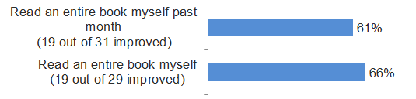
- Youth who had poor attitudes towards reading before MOBF had better attitudes towards reading after participating in the program.
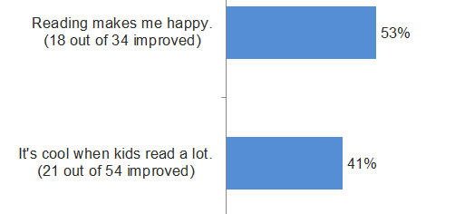
- Respondents to all three surveys agree that students are seeking out new books to read after the bookstore visit.
- Teachers reported classroom-level improvement ranging from expected short-term outcomes (e.g., enthusiasm about reading) to longer-term outcomes (e.g., reading comprehension).
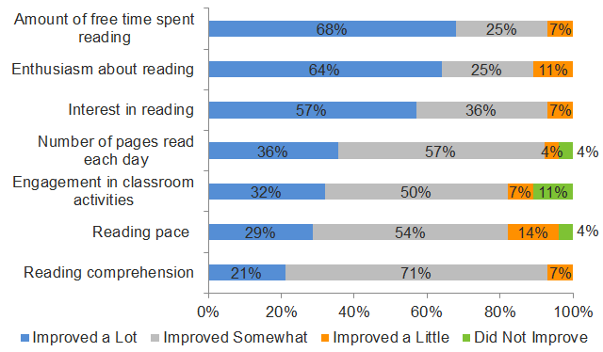
- Siblings of students who went on the MOBF bookstore visit also increased their interest and time spent reading as shown by data from the parent survey.
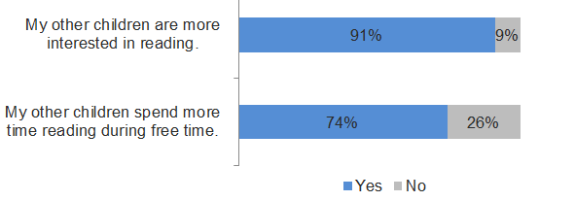
- Volunteer support to teachers, and volunteer skill at working with kids was rated very highly by teachers.

- Teachers could do more to help students make an appropriate booklist. Student data notes that while some teachers were doing this very well, teachers other schools struggled with this task.

- Adults are not reading to children before or after the program. This re-emphasizes that the target for change of the program must be the student.

